THE **** OBSERVER
www.sobserver.com THE PEOPLE’S FAVOURITE NEWSPAPER £1

POMPEII DEVASTATION!

We managed to catch up with two now-orphaned children, who were lucky to escape. Tranio [13] explained, “People were coughing, choking and being sick. I felt like I was suffocating.” Livia [12] exclaimed that she felt sorry for the animals and added that she wanted to put them all on the boat with her. “I was very worried about the poor animals - and the people! We were all in shock that it exploded - not one person knew it was a volcano. Within seconds of the eruption, a gigantic

cloud of ash and dust formed high above the volcano. It turned the sky of Pompeii black like night. People were running and panicking, and animals were pulling on their chains.”

An old man, who wishes to remain anonymous, told us, “It is such a shame that no-one will be able to live here now. All we can see is lots of ash everywhere. People will probably only find this marvellous city again in hundreds, or thousands, of years. And it is all our own fault for not doing the right thing! It is a very sad moment for anyone who lived in Pompeii.”

This is truly a devastating event. If you want any extra information, come along and see us at Observer Street. We will update you if you email us @www.***observer.com

By

Vesuvius violently exploded yesterday (the afternoon of 24th August) killing most, if not nearly all, citizens of Pompeii. It is generally thought that the Gods were angry with them – probably because people were not living decently. Men and women from far away are worried that the same might happen to them.

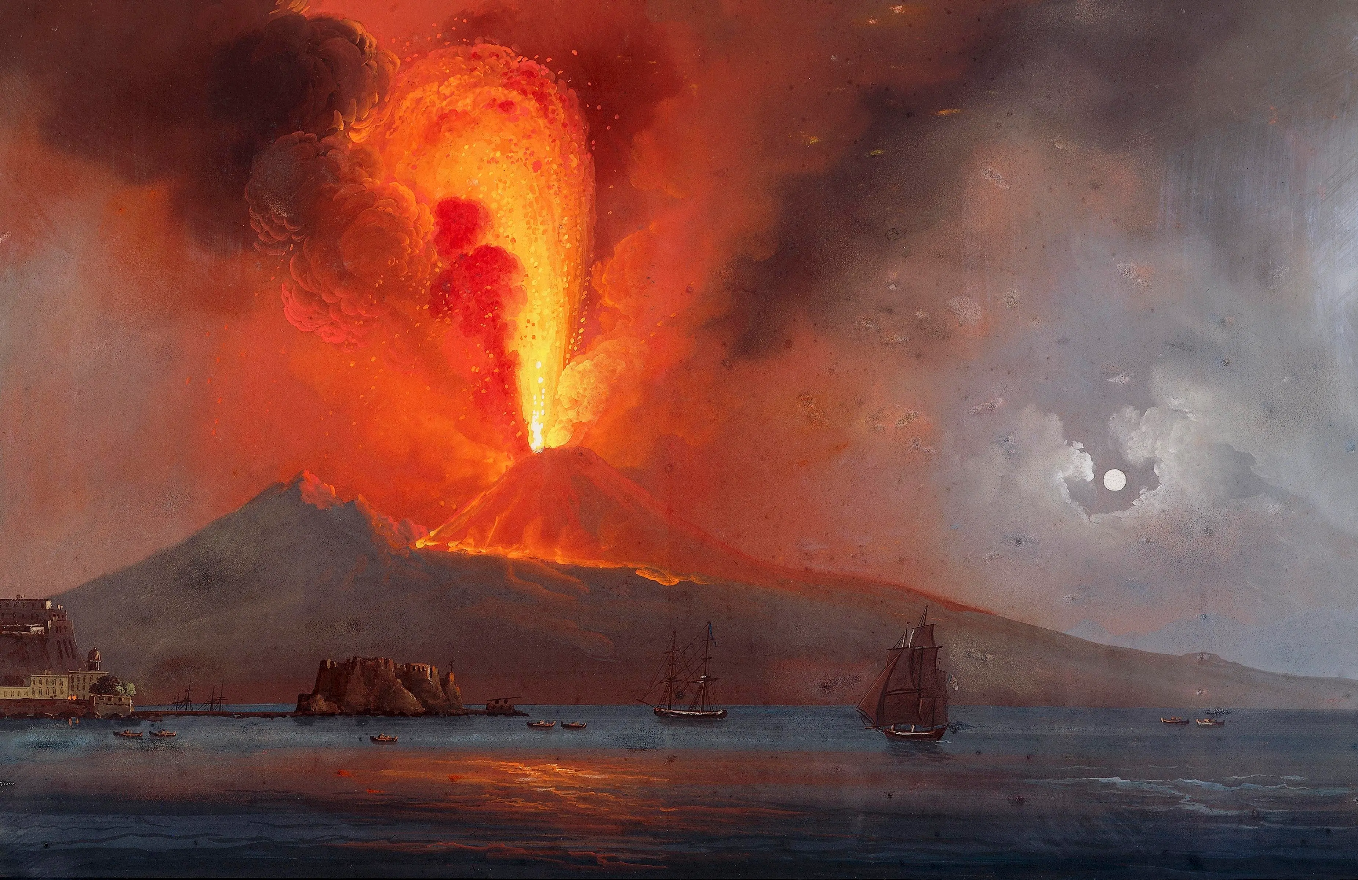
Vesuvius: Lava flowing everywhere.

